**ASSISTED PRACTICE (SMTP SAMPLER)**

Step1: Open Jmeter

Step2: Right Click on Test Plan -> Add -> Thread(users) -> Thread Group

Step3: Right Click on Thread Group -> Add -> Sampler -> SMTP Sampler

Step4: In SMTP Sampler -> Go to Server settings -> Give the server name as “smtp.gmail.com” and Port number as “587”

Step5: Now, Go to Mail settings -> Give the Address From as “our mail id” and Address To as “mail id to which we want to send the mail from our mail id”

Step6: Go to Auth Settings -> Select the checkbox “Use Auth” -> Type the username as “our mail id” and password as “our mail id password”

Step7: Go to Security settings -> Select the checkbox “Use StartTLS”

Step8: Go to Message settings -> Give any subject name we want -> Type the content of mail that we want to send to someone in the “Message” section

Step9: Right Click on Thread Group -> Add -> Listener -> View Results Tree(to see the output)

Step10: Save the program and execute it to see the result as shown below:

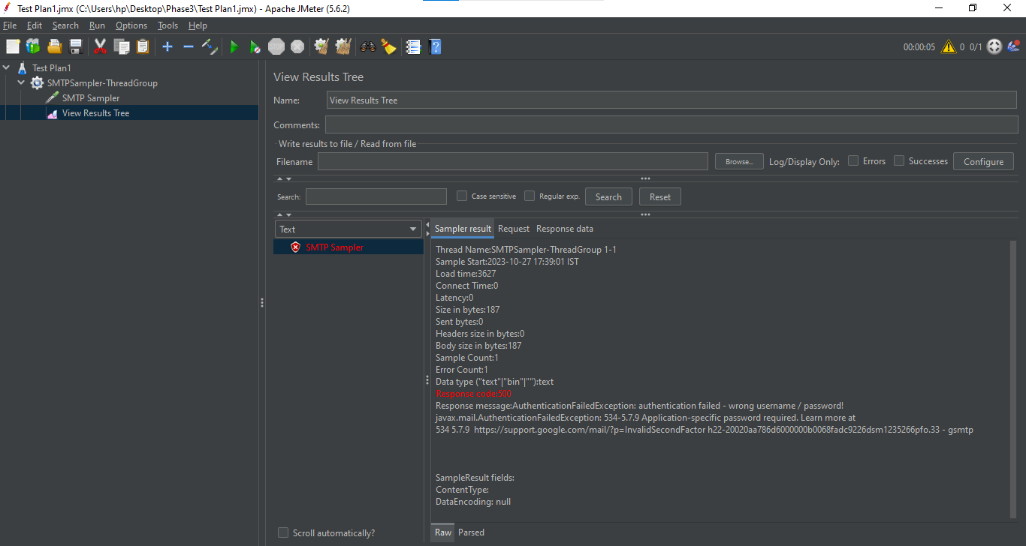

This is alright because gmail SMTP server is not allowing third party tools to use it and send emails.